

CS1021 ASSIGMENT 2

Student name: Patrick Dillon Ryan

Student Number: 17340382

*INTRODUCTION*

There were three programs to be built for this assignment

1. Sets – Symmetric Difference
2. Countdown Checker
3. Lottery

All three of these programs had to be typed up separately and are all independent of each other, unlike the previous assignment that had to be done.

1. Sets – Symmetric Difference

*“In mathematics, the symmetric difference is the set of elements which are in either of the sets and not in their intersection.”*

* *The union of sets excluding their intersection*

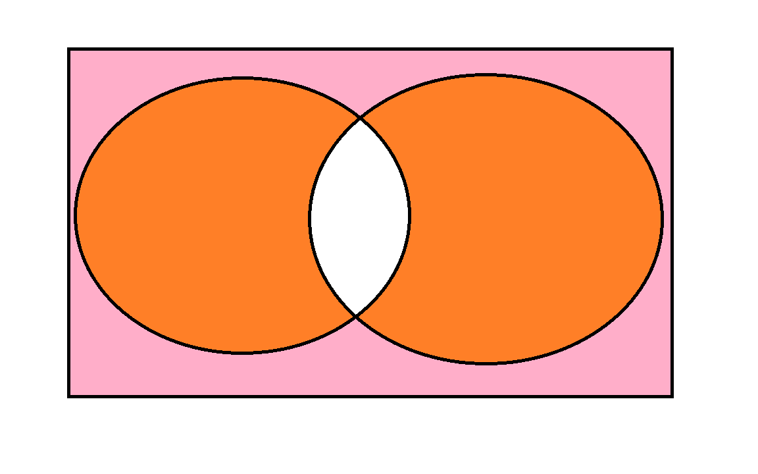

The Symmetric difference is the parts that are colored in orange.

They are all unsigned values so there are no negative numbers and the results are stored in memory. The symmetric difference is stored in C.

In order to find the symmetric difference

1. Take one elements of A
2. Look for a matching element in B
3. If there is a match the loop is exited
4. If it reaches the end of B with no match then it adds the element to C

This then has to be repeated for taking an element from B.

Pseudocode

Address elements of A

adress of elems in A

NO OF ELEMENTS

OFFESET 0

elemnets of c

OFFSET 0

elements of B

num of elems in B

load the number of elements in set B into R9

set the offset to zero

load an element from A into R0

While (Count of A != 0)

{

Adr++

SIZE COUNTER c

offset++

bElements--

while (bElements != 0)

{

adrA ++

set A count --

Load in adr of CSize into R0

Store the size of set C into R10

Results

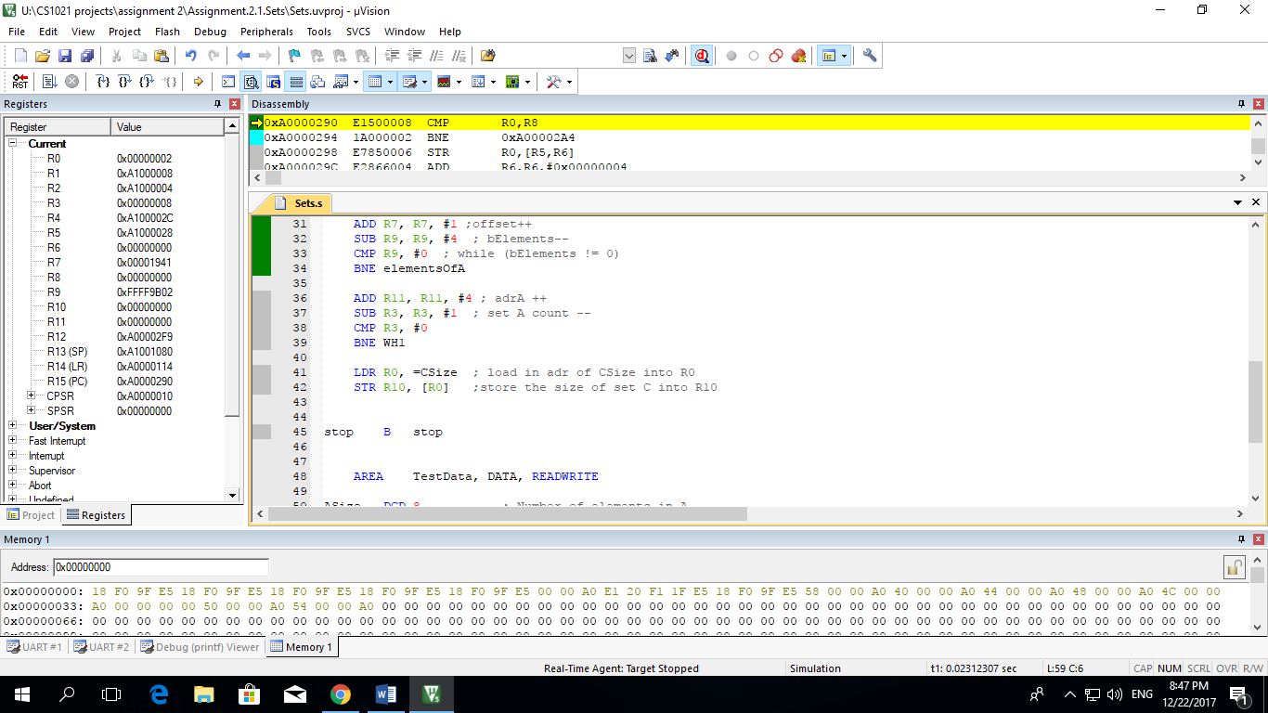

The result was to be stored in R10. Unfortunately I was unable to get the program to successfully run. The program should have given that there was 10 numbers in the symmetric difference but unfortunately it didn’t operate properly

1. Countdown Checker

In the game Countdown contestants are given nine letters and they must form words from the letters. Each letter can only be used once. Not all the letters had to be used in making the word. In this part I had to determine if one string can be made from the nine letters stored in a separate string.

The plan for this part was to delete a character once you have found a match. Then replace the character with a ‘$’

Pseudocode

Load in start adr of word

Load in start adr of letters

if possible

replacement char

ptr2 = start adr of letters

load cdWords into R12

{

load cdLetters into R10

{

if (adr1 != adr2)

{

adr2++

}

adr1++

endelemB2

if impossible

Results

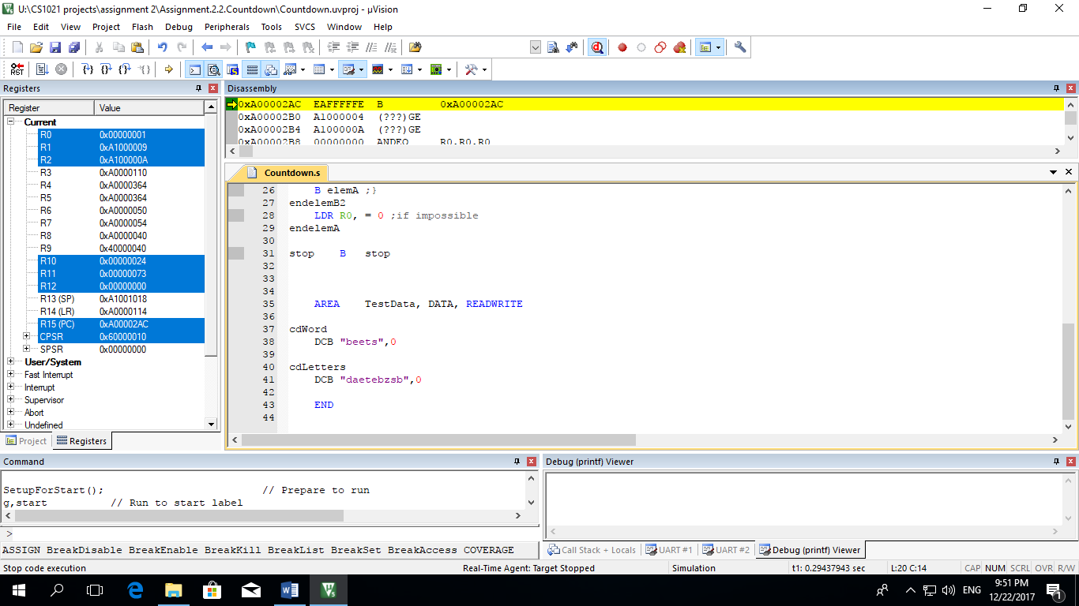

As seen in R0 there is a 1 at the end, this means that it is possible for the word to be made from the letters provided.

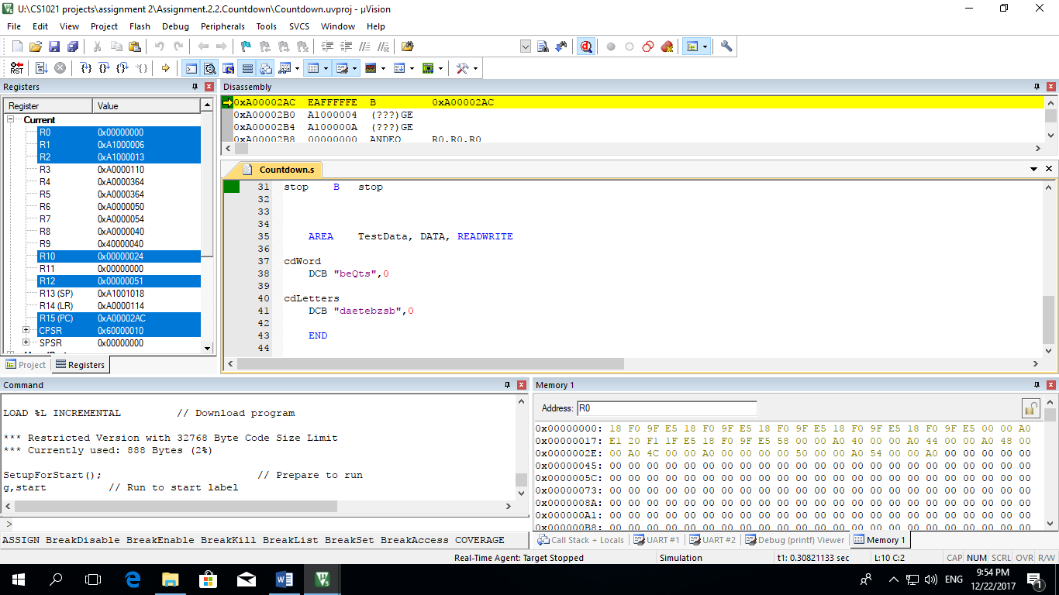As seen in R0 there is a 0, this means that it is impossible for the word to be made from the letters provided.

1. Lottery

In this lotto game players have to choose six numbers between 1 and 32. There is a prize for matching four, five or six numbers. It was needed to check which numbers match four numbers, five numbers or six numbers. All lottery numbers are stored as simple byte-size values. I must use LDRB and STRB in order to access the next value.

Adr + 1 – This moves the address to the next value

Adr + 4 – This moves it to the next word

It is assumed that there as less than 8.6 million tickets as if there were any more it would cause it to crash.

Pseudocode

Number of tickets remaining

ticketCount

setting current match count to 0

while ( ticketCount != 0 )

{

load in ticket number

start adress of new draw numbers

drawCount

while drawCount != 0

{

load in draw numbers

if ( ticket number = draw number )

{

matchCount ++

else

drawNumbers ++

drawCount--

}

TICKETS++

ticketCount--

}

NumberOfTickets--

if ( matchCount >= 4)

{

if ( matchCount = 6 )

{

load in previous number of MATCH6 tickets

MATCH6++

}

if ( matchCount = 5 )

{

load in previous number of MATCH5 tickets

MATCH5++

}

if (matchCount = 4 )

load in previous number of MATCH4 tickets

MATCH4++

}

}

if ( number of tickets remaining > 0 )

Go to ticket and go through whole loop again

Results

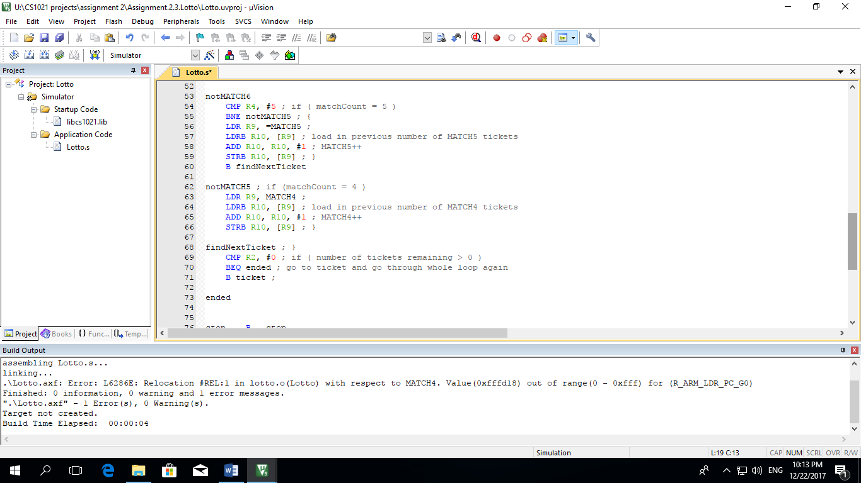

Unfortunely my program wouldn’t run due to an error. I was only able to get it to work once I took out the ‘MATCH4’ part

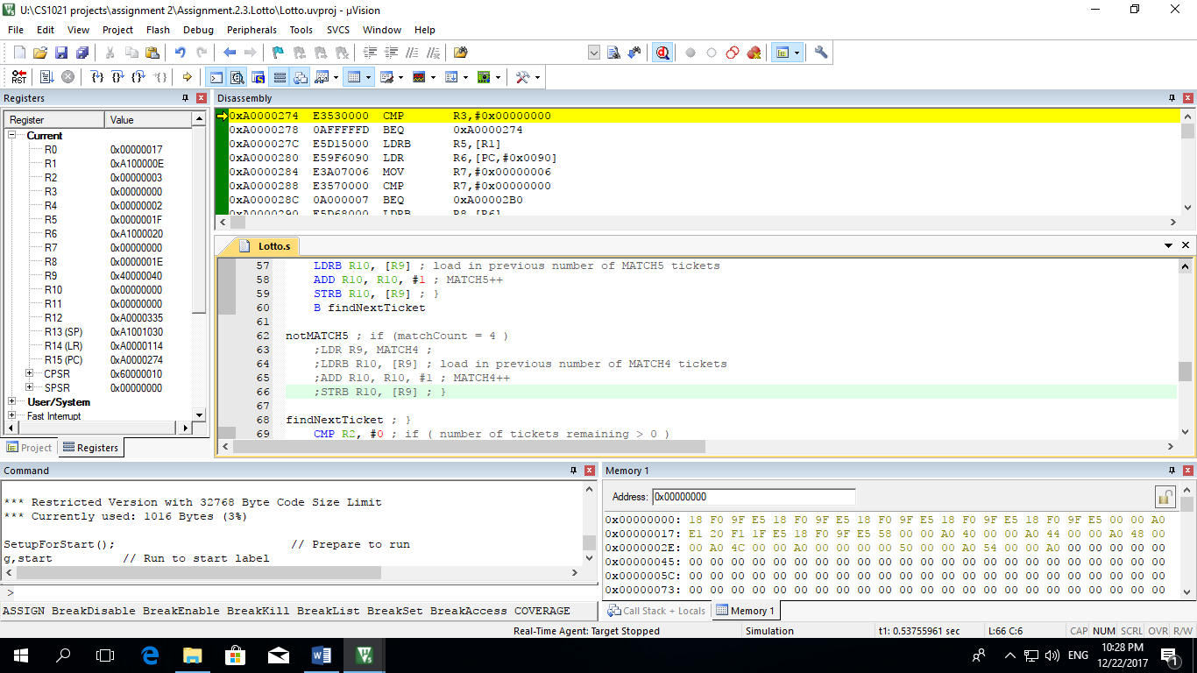

I then removed out the part that was stopping it from running and I ran the program but it didn’t run correctly and the answers were wrong.